1819-1859: FLORENCE − PLAYING-CARDS AT CASINO DEI NOBILI
Franco Pratesi, 05.12.2013

Introduction

Card playing was one of the usual activities in the Casino dei Nobili of Florence. This study involves the last forty years of that activity, which ended in 1859. Later on, the Casino remained open for conversation and parties up to 1924, when it was closed down and the whole archive of the Istituto dei Nobili was transferred into the Florentine Archivio di Stato (ASFI), where it can now be studied. A short description of the ASFI has already been inserted in a previous note. (1)
The archive section Istituto dei Nobili contains no fewer than 139 books and folders; it has been described in a long article, (2) with a useful historical introduction and a catalogue of all the documents. I had already examined this section many years ago, but could only find a couple of entries related to the history of chess. (3) In particular, the documentation on card playing is not at all uniform, and only recently I have decided to examine it in some detail.
The present study is based on an extraordinary register, (4) and a few folders of receipts associated with it. I could not yet find similar documents for the 18th century, and will report in a next note what I could collect from several sources of that time.

Casino dei Nobili in general

To define exactly what one intends as Casino dei Nobili is a rather hard task. In this context, Casino should mean a small building, but not any small building could be so named. Maybe a true synonym of Casino is Villa; if a difference between the two names can be found it is that Villa implies a rich family, Casino a rich personage − both were houses in the countryside, where the owner could rest from the stressing life of the town. In a Casino, hunting and playing were the main occupations; whereas a larger Villa was rather intended for longer stays (typically during the summertime) by the whole family, servants included.
In the 17th centuries, some Casinos appeared within the towns themselves. Here the meaning was somehow different. The owner was no longer a rich personage, but an association of them. Instead of using their own mansions for events, receptions, parties, games, a public building was established to those aims.
If this Casino was a shared residence, this did not of course mean that everybody could enter it. In our case, it was the Casino dei Nobili of Florence, which already with its name showed the limits of the frequenters, the nobility of the town.
During the time interval under examination, it was no longer a serious problem that of determining who among the Florentine inhabitants could be named a noble. They already had their Libro d’oro, where the acknowledged noble families were simply listed.
It was an essential occupation for the secretary of the community of the Florentine nobles to keep that Libro duly updated. In the Fig. 1 a letter of 1838 is reproduced in which the secretary applies to the administration for receiving monthly lists of the changes occurring in the noble families of the town − not only local births and deaths, but also news on any such event possibly having occurred out of town. Of course, if his request was met, these communications could greatly simplify his onerous responsibility.
We can thus delay to a future opportunity the question of the Florentine nobles and their selection for the frequency of the Casino. Let me just indicate that this had been a rather complex question, because the “true” (if any) ancient nobles of Tuscany had been strongly fought against by the Florentine community, ending with the subsequent birth of different kinds of new nobles in the following centuries.

Casino dei Nobili di Santa Trinita

The history of the Florentine Casino dei Nobili is rather complex too, especially for its initial years. However, already in 1761 the various co-existing companies had decided to join together into the Casino di Santa Trinita, as the sole such institution at the town level, which could thus properly receive the name of Casino dei Nobili di Firenze.
Actually, we should speak of an Istituto dei Nobili, which had two main branches, the Accademia, and the Casino. The Accademia was really established in this instance for “academic” aims, namely for educating the noble youth; the “cadets” had several subjects to learn, ranging from humanities to riding. The Casino was instead devoted to more pleasant activities, as indicated above, with conversation, parties, and similar events, in addition to the possibility of playing several games every day – card games included, even when they were forbidden almost everywhere else in Tuscany.

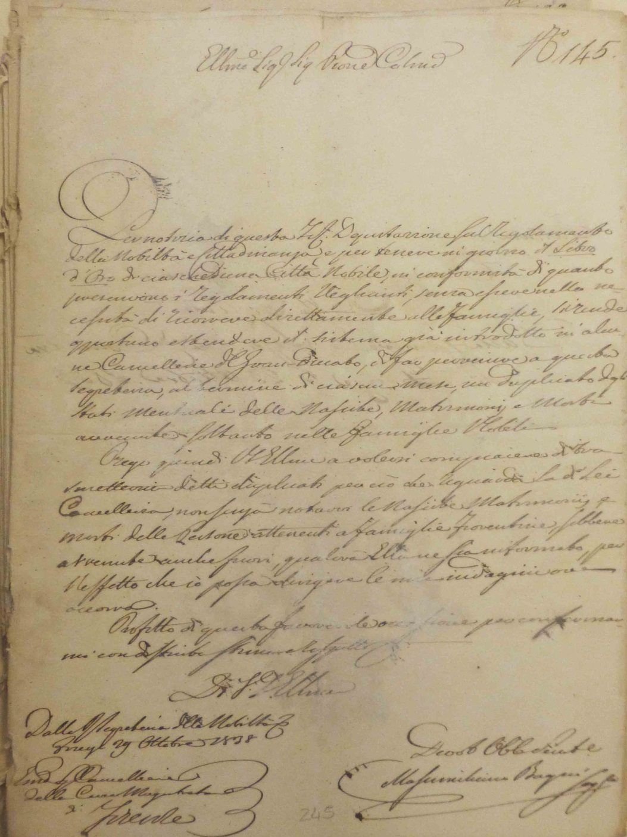

Figure 1 – Letter of 29 October 1838, see text (ASCFI, CA 227, Aff. 145)
Su concessione dell’Archivio storico del Comune di Firenze (5)

In both cases of Accademia and Casino, foreign nobles could take part. This admission was not immediate, but required certifications, checking them, the introduction by a local noble, and the conclusive approval by the council. Long lists of foreign nobles spending some time in Florence and taking part in those activities can be read in the Istituto dei Nobili section of the ASFI; no fewer than twenty registers among those kept in the ASFI were exclusively compiled with such records.

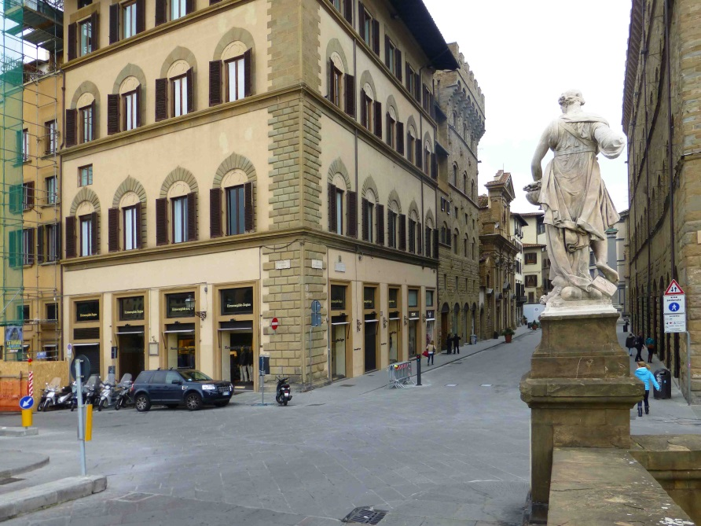

Figure 2 – Via Tornabuoni and Lungarno Corsini, from Santa Trinita bridge.

The main seat of the Accademia was located within the Palazzo Strozzi, the prestigious palace in the centre of Florence; several buildings near the palace were also involved in its activity.
The building, which housed the Casino, was instead near the Santa Trinita bridge. Most of the area (or it entirely in certain times) between the church of Santa Trinita and the Arno river was owned by several branches of the Gianfigliazzi family, and records of rent money paid to them are frequently found in the registers of the Istituto dei Nobili section.

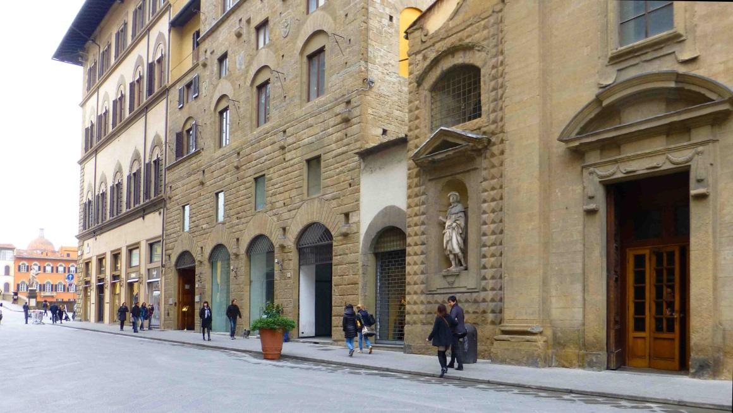

Figure 3 – Via Tornabuoni, from Santa Trinita church to Lungarno Corsini.

It is not clear to me which was the exact location of the Casino, and especially how it changed in the course of time. However, its central place apparently was the building at the corner between Via Tornabuoni and Lungarno Corsini, just in front of the Santa Trinita bridge. Two views of that building, as seen nowadays from opposite points of view, are inserted here, as Figs. 2 and 3.
In the time interval under examination, however, the Casino had also occupied some of the neighbouring palaces, certainly that nearer to the church, where several shops had existed earlier on.

Register 105 and folders of receipts in the section Istituto dei Nobili

The register No. 105 is an unbelievably comprehensive register, with all the records of incomes and expenses of Casino from 1815 to 1875. As it could be expected, it is a large-format book, 42x28cm; its thickness is also remarkable, due both to its almost 300 folios (171 written), and the thickness itself of the paper sheets used. Actually, the time interval of its contents is longer than strictly required for our aims: in particular, both the initial and especially the final parts do not contain records of playing-card consumption, which we are interested in.
“Our” information can be found collected in separate sections expressly devoted to card trade; the corresponding folios are indicated in the appendix, where all these entries have been copied. In the following discussion, I will simply use the yearly amounts that can be derived from the whole set of data, as shown in the corresponding table below.
There are some important points to be indicated beforehand. All the numbers of the table have been derived from the elements recorded in the register (with a few exceptions, see below); none of them is expressly indicated in the register. To be sure, one may again add together the corresponding values of the appendix and check if the sums reported are correct.
There is however a further step, which is harder to perform. Actually, the individual entries in the register do not correspond to individual purchases from the cardmakers. It usually was one of the keepers of the casino to pick up the cards from the cardmaker, about once in a month or whenever needed. The individual purchases from the cardmaker were noted and the score settled once in a while.
Often, the cardmakers do not even appear in the register: it is the keeper to be recorded while receiving the money that he had given (or had to give) to the cardmaker. In order to perform a more accurate study, it should be necessary to study all the receipts, containing more detailed information. The accession number of these receipts is provided in the second column of the lists in the appendix.
In the same section of Istituto dei Nobili, the folders with the receipts gathered together are catalogued as follows:
No. | Years
119 | 1816-21
120 | 1822-28
121 | 1829-34
123 | 1835-40
124 | 1841-46
125 | 1847-52
126 | 1853-57
127 | 1856-66

I only have checked a few of them, in part as a random sample to verify the data, in part to insert a few values that were missing in the register. What is evident in these files, is that there did not exist any theatre activity associated with this Casino: if that were the case, more researchers would have already inspected these folders, whereas they appear to have been kept untouched for many decades.
The typical receipt is a sheet of paper with several individual notes from the cardmaker (or, in case, the cardmakers) pinned together. It is these individual receipts that may provide an almost full satisfaction to a future researcher, patient enough to complete this study.
It will then be possible to ascertain who exactly were the cardmakers involved and which were the precise costs of the cards supplied. As for cardmakers, a few of the well-known names of the time are mentioned here, such as Giuseppe Baragioli, Pasquale Falugi, Cosimo Adami, Placido Zanobetti. The general impression is that most if not all of the cardmakers active at the time were involved.
As for the prices of the cards, often whole numbers of Lire are found to correspond to a dozen packs; typically, a dozen of 40-card packs (Basse) was sold for 14L., of 52-card packs (Picchetti) for 16L. and of Minchiate for 20L.
Both in the register No. 105, and in the receipts of the folders indicated, information can be found on second-hand cards sold back by the Casino. Indicative prices for this trade, for dozens, were for a long time 8L. for Basse and 10L. for Picchetti. Usually, the indication was simply provided that those second-hand cards were sold back at the usual prices, ai soliti prezzi; only for the last sales of 1858 the price had increased up to 10L. for Basse and 12L. for Picchetti.
The money amounts of the purchases are reported in the appendix; they are not always directly correlated with the amounts of new packs acquired, because in several cases, and especially in the years 1824-27, the payment partly occurred with second-hand cards sold back to the maker.

The yearly purchases of playing-cards

The following table contains the relevant information, reduced to yearly inputs.

Year | Basse | Picchetti | Minchiate | Total
1819 | 86 | 0 | 12 | 98
1820 | 78 | 0 | 32 | 110
1821 | 66 | 0 | 6 | 72
1822 | 60 | 4 | 0 | 64
1823 | 184 | 0 | 0 | 184
1824 | 352 | 0 | 6 | 358
1825 | 390 | 0 | 4 | 394
1826 | 348 | 0 | 54 | 402
1827 | 822 | 0 | 8 | 830
1828 | 1242 | 0 | 6 | 1248
1829 | 958 | 0 | 10 | 968
1830 | 486 | 0 | 0 | 486
1831 | 1298 | 0 | 6 | 1304
1832 | 1254 | 0 | 0 | 1254
1833 | 1444 | 0 | 0 | 1444
1834 | 504 | 1348 | 0 | 1852
1835 | 204 | 1254 | 0 | 1458
1836 | 330 | 348 | 6 | 684
1837 | 258 | 564 | 0 | 822
1838 | 114 | 1026 | 64 | 1204
1839 | 252 | 552 | 80 | 884
1840 | 180 | 848 | 36 | 1064
1841 | 48 | 942 | 0 | 990
1842 | 72 | 1212 | 0 | 1284
1843 | 36 | 1284 | 0 | 1320
1844 | 36 | 920 | 6 | 962
1845 | 12 | 1140 | 0 | 1152
1846 | 0 | 1488 | 0 | 1488
1847 | 0 | 1212 | 0 | 1212
1848 | 0 | 1248 | 0 | 1248
1849 | 0 | 960 | 0 | 960
1850 | 0 | 864 | 0 | 864
1851 | 0 | 1140 | 0 | 1140
1852 | 0 | 468 | 0 | 468
1853 | 0 | 348 | 0 | 348
1854 | 0 | 468 | 0 | 468
1855 | 0 | 638 | 0 | 638
1856 | 0 | 120 | 0 | 120
1857 | 0 | 276 | 0 | 276
1858 | 0 | 552 | 0 | 552
1859 | 0 | 348 | 0 | 348

The most striking evidence in the table is the sudden appearance of Picchetti packs in 1834. This evidence may recall a similar event that had occurred a dozen years before in the Stanze of Cocomero theatre. (6) It is almost certain, however, that Picchetti packs were also increasingly used in the Casino during a few previous years, and not only for the case attested of the four packs recorded for 1822.
What really occurred in 1834 was not a new introduction of 52-card packs, but just a new way of separately recording Basse and Picchetti. An unknown fraction of Picchetti was present among the packs of Basse indicated for the previous years. This too may be an object for a future accurate research on the folders with the corresponding receipts.
Actually, we may be interested in distinguishing the two kinds of packs, especially if we are looking for the spread of the Whist game, which could not be played with the 40-card pack. In the possible associations of a given kind of packs with the corresponding games, we cannot similarly deal with the vice versa situation: traditional card games that required the 40-card packs could be played with any complete pack after removing all the 8s, 9s and 10s.
In particular, it is far from proved that only the 52-card pack was used during the last dozen years with available records. There are indications both that games of the Tressette family were still played by then, and that, unexpectedly, second-hand 40-card packs were recorded as sold back even in the last years. In conclusion, there is some ambiguity in our data as for the fraction of 40- and 52-card packs actually used, and for which games.
The particular information that cannot be questioned at all is, as in similar case, that related to Minchiate packs. Year after year, we can follow the favour of this pack both in itself, and in comparison with the other kinds of cards in common use.
The result is rather disappointing, because it indicates that the Florentine nobles played less Minchiate than, typically, their fellow citizens of the Stanze of Cocomero. Moreover, the general decrease in popularity that the game suffered everywhere appears to have occurred earlier and more drastically in Casino dei Nobili than in other gaming houses of the time.
A possible explanation − should it be worthwhile to propose one of them − may be connected with the frequency of foreign visitors, who could play Whist more comfortably than Minchiate.

Notes

1. http://trionfi.com/notary-ser-giovanni-bandini ; www.naibi.net/A/132
2. Elios Maffei, “L'archivio dell'Istituto o Casino dei Nobili di Firenze”. Archivio storico italiano, 2 (1967) 246-265.
3. Franco Pratesi, “Gli scacchi dei nobili lasciano traccia”. Scacco, 22 N. 9 (1991) 386-387.
4. ASFI, Istituto dei Nobili, 105
5. www.comune.fi.it/archiviostorico
6. www.naibi.net/A/228 ; http://trionfi.com/ev28

APPENDIX − Records From Register No. 105

The sections we are interested in can be found at folios 1, 18, 23, 32, 40, 47, 48, 54, 60, 62, 64, 68, 74, 76, 78, 85, 90, 91, 97, 103, 106, 112, 114, 131, 139.
The amount of records per year is remarkably different, but this generally corresponds to different amounts of individual purchases settled with a given payment. (The indication of zero packs in the table corresponds to missing records.)

Year | mmdd | Receipt | Basse | Picchetti | Minchiate | Payment
1819 | 0731 | 35 | 6 | 0 | 0 | 1
 | 0731 | 47 | 56 | 0 | 12 | 13.3
 | 1231 | 56 | 24 | 0 | 0 | 4
1820 | 0229 | 6 | 30 | 0 | 18 | 9.3
 | 0331 | 17 | 30 | 0 | 8 | 6.6.13.4
 | 1231 | 35 | 18 | 0 | 6 | 4.1
1821 | 0430 | 15 | 32 | 0 | 6 | 7.-.13.4
 | 0731 | 26 | 18 | 0 | 0 | 3
 | 1231 | 45 | 16 | 0 | 0 | 2.5.6.8
1822 | 0430 | 13 | 24 | 4 | 0 | 5.5.6.8
 | 0831 | 26 | 18 | 0 | 0 | 3
 | 1231 | 40 | 18 | 0 | 0 | 3
1823 | 0326 | 23 | 72 | 0 | 0 | 12.1.13.4
 | 0630 | 35 | 28 | 0 | 0 | 4.5.6.8
 | 1231 | 66 | 84 | 0 | 0 | 15.4
1824 | 0331 | 18 | 184 | 0 | 6 | 33.1.6.8
 | 0630 | 34 | 42 | 0 | 0 | 6.6
 | 0930 | 51 | 66 | 0 | 0 | 10.6
 | 1231 |  | 60 | 0 | 0 | 5
1825 | 0331 | 10 | 180 | 0 | 0 | 16.3
 | 0731 | 26 | 102 | 0 | 0 | 10.6.10
 | 1231 | 57 | 108 | 0 | 4 | 12.5
1826 | 0228 | 4 | 96 | 0 | 6 | 13.3
 | 0731 | 24 | 144 | 0 | 30 | 22.4
 | 1231 | 46 | 108 | 0 | 18 | 16.3.5
1827 | 0331 | 7 | 336 | 0 | 8 | 45.1.6.8
 | 0531 | 20 | 132 | 0 | 0 | 17.1
 | 0831 | 34 | 108 | 0 | 0 | 14
 | 1231 | 61 | 246 | 0 | 0 | 31.6.10
1828 | 0331 | 12 | 498 | 0 | 0 | 62.2.10
 | 0731 | 24 | 318 | 0 | 0 | 41.4.10
 | 1231 | 58 | 426 | 0 | 6 | 56
1829 | 0401 | 16 | 646 | 0 | 0 | 81.3.10
 | 0731 | 22 | 192 | 0 | 0 | 24.6
 | 1231 | 50 | 120 | 0 | 10 | 17.1.13.4
1830 | 0301 | 7 | 228 | 0 | 0 | 27.4
 | 0331 | 45 | 66 | 0 | 0 | 8.2.10
 | 0630 | 6 | 144 | 0 | 0 | 18.4
 | 0809 | 11 | 48 | 0 | 0 | 6.2
1831 | 0327 | 8 | 494 | 0 | 6 | 66
 | 0630 | 32 | 336 | 0 | 0 | 44
 | 1130 | 69 | 348 | 0 | 0 | 46.2.10
 | 1231 | 74 | 120 | 0 | 0 | 15.5
1832 | 0131 | 9 | 150 | 0 | 0 | 19.4.10
 | 0331 | 8 | 426 | 0 | 0 | 55.5.10
 | 0731 | 24 | 234 | 0 | 0 | 32.3
 | 1130 | 47 | 264 | 0 | 0 | 50.2
 | 1231 | 50 | 180 | 0 | 0 | 34.2
1833 | 0331 | 7 | 414 | 0 | 0 | 78.6
 | 0731 | 20 | 564 | 0 | 0 | 107.1
 | 1231 | 49 | 466 | 0 | 0 | 89.6
1834 | 0630 | 17 | 300 | 644 | 0 | 172.4.13.4
 | 0927 | 22 | 120 | 252 | 0 | 68
 | 1231 | ? | 84 | 452 | 0 | 98.4
1835 | 0131 | 3 | 36 | 276 | 0 | 70
 | 0228 | 6 | 18 | 228 | 0 | 46.3
 | 0331 | 11 | 30 | 162 | 0 | 35.6
 | 0427 | 16 | 12 | 120 | 0 | 24.6
 | 0630 | 21 | 24 | 198 | 0 | 41.5
 | 0831 | 28 | 18 | 102 | 0 | 22.3
 | 1117 | 59 | 18 | 90 | 0 | 20.1
 | 1231 | 66 | 48 | 78 | 0 | 22.6
1836 | 0224 | 2 | 108 | 138 | 0 | 44.2
 | 0513 | 17 | 102 | 60 | 0 | 28.3
 | 0630 | 24 | 24 | 24 | 6 | 10.2
 | 0831 | 29 | 12 | 12 | 0 | 4.2
 | 1130 | 52 | 36 | 84 | 0 | 15.1
 | 1231 | 56 | 48 | 30 | 0 | 13.5
1837 | 0131 | 1 | 30 | 36 | 0 | 11.6
 | 0331 | 10 | 84 | 186 | 0 | 49.3
 | 0630 | 19 | 42 | 216 | 0 | 48.1
 | 0930 | 46 | 42 | 60 | 0 | 18.3
 | 1130 | 62 | 24 | 24 | 0 | 8.4
 | 1231 | 79 | 36 | 42 | 0 | 14
1838 | 0228 | 3 | 42 | 300 | 0 | 57.2
 | 0830 | 36 | 42 | 378 | 12 | 82.3
 | 0830 | 38 | 18 | 36 | 16 | 14.3
 | 0929 | 51 | 0 | 48 | 24 | 16
 | 1130 | 62 | 12 | 144 | 0 | 29.4
 | 1231 | 70 | 0 | 120 | 12 | 26.2
1839 | 0131 | 2 | 0 | 36 | 8 | 28.4
 | 0228 | 10 | 12 | 84 | 12 | 21.3
 | 0331 | 20 | 0 | 48 | 0 | 9.1
 | 0430 | 25 | 24 | 48 | 12 | 16.4
 | 0531 | 28 | 48 | 36 | 12 | 18.2
 | 0701 | 35 | 24 | 72 | 12 | 21.1
 | 0731 | 41 | 12 | 36 | 0 | 8.6
 | 0831 | 49 | 24 | 24 | 6 | 10.2
 | 0630 | 52 | 36 | 12 | 6 | 10
 | 1031 | 62 | 12 | 48 | 6 | 12.6
 | 1130 | 64 | 36 | 36 | 6 | 14.4
 | 1231 | 75 | 24 | 72 | 0 | 17.5
1840 | 0131 | 2 | 42 | 144 | 6 | 36.1
 | 0229 | 11 | 30 | 152 | 6 | 29.4
 | 0331 | 14 | 12 | 108 | 18 | 27.5
 | 0430 | 26 | 12 | 60 | 0 | 13.3
 | 0531 | 28 | 12 | 60 | 0 | 13.3
 | 0630 | 37 | 12 | 24 | 0 | 6.4
 | 0731 | 47 | 0 | 24 | 0 | 4.4
 | 0831 | 48 | 12 | 36 | 0 | 8.6
 | 0930 | 56 | 12 | 36 | 0 | 8.6
 | 1031 | 58 | 0 | 60 | 0 | 11.3
 | 1130 | 64 | 24 | 72 | 0 | 17.5
 | 1231 | 86 | 12 | 72 | 6 | 18.-.13.4
1841 | 0131 | 4 | 12 | 120 | 0 | 24.6
 | 0228 | 11 | 12 | 132 | 0 | 27.1
 | 0331 | 16 | 0 | 138 | 0 | 26.2
 | 0430 | 21 | 12 | 72 | 0 | 15.5
 | 0630 | 35 | 0 | 24 | 0 | 4.4
 | 0630 | 37 | 0 | 60 | 0 | 11.3
 | 0731 | 41 | 0 | 24 | 0 | 4.4
 | 0831 | 80 | 0 | 36 | 0 | 6.6
 | 0930 | 82 | 0 | 48 | 0 | 9.1
 | 1031 | 94 | 0 | 48 | 0 | 9.1
 | 1130 | 98 | 12 | 108 | 0 | 22.4
 | 1231 | 107 | 0 | 132 | 0 | 25.1
1842 | 0131 | 2 | 12 | 132 | 0 | 27.1
 | 0228 | 6 | 0 | 156 | 0 | 29.5
 | 0331 | 17 | 12 | 120 | 0 | 24.6
 | 0430 | 21 | 0 | 132 | 0 | 25.1
 | 0531 | 31 | 12 | 120 | 0 | 24.6
 | 0630 | 42 | 0 | 84 | 0 | 16
 | 0731 | 48 | 12 | 36 | 0 | 10.4
 | 0831 | 52 | 12 | 36 | 0 | 8.6
 | 0930 | 65 | 0 | 48 | 0 | 9.1
 | 1031 | 71 | 12 | 84 | 0 | 18
 | 1130 | 75 | 0 | 120 | 0 | 22.6
 | 1231 | 84 | 0 | 144 | 0 | 27.3
1843 | 0131 | 1 | 0 | 168 | 0 | 32
 | 0228 | 7 | 0 | 132 | 0 | 25.1
 | 0331 | 18 | 12 | 168 | 0 | 34
 | 0430 | 33 | 0 | 96 | 0 | 18.2
 | 0531 | 37 | 0 | 132 | 0 | 25.1
 | 0630 | 47 | 0 | 108 | 0 | 20.4
 | 0731 | 54 | 0 | 84 | 0 | 16
 | 0831 | 62 | 12 | 48 | 0 | 11.1
 | 0930 | 68 | 0 | 72 | 0 | 13.5
 | 1031 | 76 | 12 | 96 | 0 | 20.2
 | 1130 | 83 | 0 | 72 | 0 | 13.5
 | 1231 | 85 | 0 | 108 | 0 | 20.4
1844 | 0131 | 1 | 0 | 96 | 0 | 22.6
 | 0229 | 6 | 12 | 120 | 6 | 32.6
 | 0331 | 21 | 0 | 108 | 0 | 25.5
 | 0430 | 26 | 0 | 72 | 0 | 17.1
 | 0531 | 35 | 12 | 60 | 0 | 16.6
 | 0630 | 44 | 0 | 72 | 0 | 17.1
 | 0731 | 51 | 12 | 60 | 0 | 16.6
 | 0831 | 52 | 0 | 60 | 0 | 14.2
 | 0930 | 61 | 0 | 60 | 0 | 14.2
 | 1031 | 65 | 0 | 24 | 0 | 5.5
 | 1231 | 82 | 0 | 188 | 0 | 49.1.13.4
1845 | 0131 | 2 | 0 | 96 | 0 | 25.1
 | 0228 | 6 | 0 | 48 | 0 | 12.4
 | 0331 | 15 | 0 | 72 | 0 | 18.6
 | 0430 | 23 | 0 | 84 | 0 | 22
 | 0531 | 29 | 12 | 84 | 0 | 24.6
 | 0630 | 38 | 0 | 108 | 0 | 28.2
 | 0731 | 46 | 0 | 96 | 0 | 25.1
 | 0831 | 52 | 0 | 72 | 0 | 18.6
 | 0930 | 62 | 0 | 96 | 0 | 25.1
 | 1031 | 68 | 0 | 96 | 0 | 25.1
 | 1129 | 76 | 0 | 108 | 0 | 28.2
 | 1231 | 85 | 0 | 180 | 0 | 47.1
1846 | 0131 | 1 | 0 | 168 | 0 | 44
 | 0228 | 6 | 0 | 144 | 0 | 37.5
 | 0331 | 13 | 0 | 168 | 0 | 44
 | 0430 | 21 | 0 | 120 | 0 | 31.3
 | 0531 | 25 | 0 | 120 | 0 | 28
 | 0630 | 38 | 0 | 120 | 0 | 31.3
 | 0731 | 46 | 0 | 84 | 0 | 22
 | 0831 | 59 | 0 | 84 | 0 | 22
 | 0930 | 64 | 0 | 120 | 0 | 31.3
 | 1031 | 69 | 0 | 120 | 0 | 31.3
 | 1130 | 74 | 0 | 120 | 0 | 31.3
 | 1231 | 79 | 0 | 120 | 0 | 31.3
1847 | 0131 | 1 | 0 | 108 | 0 | 28.2
 | 0228 | 5 | 0 | 96 | 0 | 25.1
 | 0331 | 16 | 0 | 108 | 0 | 28.2
 | 0430 | 26 | 0 | 108 | 0 | 28.2
 | 0531 | 31 | 0 | 120 | 0 | 31.3
 | 0630 | 41 | 0 | 96 | 0 | 25.1
 | 0731 | 47 | 0 | 96 | 0 | 25.1
 | 0831 | 57 | 0 | 48 | 0 | 12.4
 | 0930 | 65 | 0 | 72 | 0 | 18.6
 | 1031 | 70 | 0 | 144 | 0 | 37.5
 | 1130 | 78 | 0 | 96 | 0 | 25.1
 | 1231 | 82 | 0 | 120 | 0 | 31.3
1848 | 0131 | 1 | 0 | 168 | 0 | 44
 | 0229 | 9 | 0 | 168 | 0 | 44
 | 0331 | 17 | 0 | 156 | 0 | 40.6
 | 0430 | 29 | 0 | 120 | 0 | 31.3
 | 0531 | 35 | 0 | 144 | 0 | 37.5
 | 0630 | 42 | 0 | 60 | 0 | 15.5
 | 0731 | 46 | 0 | 48 | 0 | 12.4
 | 0831 | 55 | 0 | 36 | 0 | 9.3
 | 0930 | 64 | 0 | 60 | 0 | 15.5
 | 1031 | 69 | 0 | 60 | 0 | 15.5
 | 1130 | 74 | 0 | 108 | 0 | 28.2
 | 1231 | 83 | 0 | 120 | 0 | 31.3
1849 | 0131 | 2 | 0 | 132 | 0 | 34.4
 | 0228 | 9 | 0 | 84 | 0 | 22
 | 0331 | 21 | 0 | 96 | 0 | 25.1
 | 0430 | 24 | 0 | 60 | 0 | 15.5
 | 0531 | 28 | 0 | 84 | 0 | 22
 | 0630 | 33 | 0 | 60 | 0 | 15.5
 | 0731 | 37 | 0 | 60 | 0 | 15.5
 | 0831 | 46 | 0 | 60 | 0 | 15.5
 | 0930 | 53 | 0 | 84 | 0 | 22
 | 1031 | 58 | 0 | 84 | 0 | 22
 | 1130 | 60 | 0 | 84 | 0 | 22
 | 1231 | 69 | 0 | 72 | 0 | 18.6
1850 | 0131 | 1 | 0 | 120 | 0 | 31.3
 | 0228 | 10 | 0 | 108 | 0 | 28.2
 | 0331 | 19 | 0 | 96 | 0 | 25.1
 | 0430 | 26 | 0 | 120 | 0 | 31.3
 | 0531 | 30 | 0 | 72 | 0 | 18.6
 | 0630 | 36 | 0 | 48 | 0 | 12.4
 | 0731 | 42 | 0 | 48 | 0 | 12.4
 | 0831 | 50 | 0 | 48 | 0 | 12.4
 | 0930 | 59 | 0 | 48 | 0 | 12.4
 | 1031 | 66 | 0 | 48 | 0 | 12.4
 | 1130 | 74 | 0 | 36 | 0 | 9.3
 | 1231 | 82 | 0 | 72 | 0 | 18.6
1851 | 0131 | 6 | 0 | 156 | 0 | 40.6
 | 0228 | 8 | 0 | 108 | 0 | 28.2
 | 0331 | 13 | 0 | 120 | 0 | 31.3
 | 0430 | 26 | 0 | 108 | 0 | 28.2
 | 0531 | 30 | 0 | 132 | 0 | 34.4
 | 0630 | 35 | 0 | 84 | 0 | 22
 | 0731 | 42 | 0 | 84 | 0 | 22
 | 0831 | 52 | 0 | 60 | 0 | 15.5
 | 0930 | 56 | 0 | 72 | 0 | 18.6
 | 1031 | 64 | 0 | 72 | 0 | 18.6
 | 1130 | 67 | 0 | 72 | 0 | 18.6
 | 1231 | 75 | 0 | 72 | 0 | 18.6
1852 | 0131 | 3 | 0 | 120 | 0 | 31.3
 | 0228 | 9 | 0 | 72 | 0 | 18.6
 | 0331 | 21 | 0 | 48 | 0 | 12.4
 | 0430 | 26 | 0 | 48 | 0 | 12.4
 | 0531 | 30 | 0 | 36 | 0 | 9.3
 | 0630 | 37 | 0 | 36 | 0 | 9.3
 | 0731 | 43 | 0 | 24 | 0 | 6.2
 | 1130 | 58 | 0 | 48 | 0 | 12.4
 | 1231 | 63 | 0 | 36 | 0 | 9.3
1853 | 0131 | 3 | 0 | 72 | 0 | 18.6
 | 0228 | 9 | 0 | 60 | 0 | 15.5
 | 0331 | 24 | 0 | 60 | 0 | 15.5
 | 0430 | 27 | 0 | 24 | 0 | 6.2
 | 0531 | 30 | 0 | 36 | 0 | 9.3
 | 0630 | 37 | 0 | 24 | 0 | 6.2
 | 0930 | 54 | 0 | 72 | 0 | 18.6
 | 1130 | 63 | 0 |  | 0
 | 1231 | 67 | 0 |  | 0
1854 | 0131 | 1 | 0 | 36 | 0 | 9.3
 | 0228 | 7 | 0 | 48 | 0 | 12.4
 | 0331 | 20 | 0 | 60 | 0 | 15.5
 | 0430 | 23 | 0 | 60 | 0 | 15.5
 | 0531 | 29 | 0 | 24 | 0 | 6.2
 | 0630 | 35 | 0 | 12 | 0 | 3.1
 | 0831 | 47 | 0 | 12 | 0 | 3.1
 | 0930 | 55 | 0 | 24 | 0 | 6.2
 | 1031 | 57 | 0 | 36 | 0 | 9.3
 | 1130 | 61 | 0 | 60 | 0 | 15.5
 | 1231 | 66 | 0 | 96 | 0 | 25.1
1855 | 0131 | 2 | 0 | 120 | 0 | 31.3
 | 0228 | 14 | 0 | 132 | 0 | 34.4
 | 0331 | 20 | 0 | 132 | 0 | 34.4
 | 0430 | 24 | 0 | 84 | 0 | 22
 | 0531 | 29 | 0 | 84 | 0 | 22
 | 0630 | 33 | 0 | 28 | 0 | 7.2.6.8
 | 0731 | 40 | 0 | 34 | 0 | 8.6.6.8
 | 0831 | 47 | 0 | 24 | 0 | 6.2
1856 | 0531 | 31 | 0 | 120 | 0 | 31.3
1857 | 0131 | 5 | 0 | 120 | 0 | 29.3.13.4
 | 0531 | 31 | 0 | 120 | 0 | 29.3.13.4
 | 1231 | 81 | 0 | 36 | 0 | 8.6
1858 | 0131 | 8 | 0 | 60 | 0 | 14.5.6.8
 | 0228 | 16 | 0 | 48 | 0 | 11.5.13.4
 | 0331 | 24 | 0 | 60 | 0 | 14.5.6.8
 | 0430 | 30 | 0 | 60 | 0 | 14.5.6.8
 | 0514 | 36 | 0 | 36 | 0 | 8.6
 | 0901 | 62 | 0 | 144 | 0 | 35.3
 | 1002 | 71 | 0 | 144 | 0 | 35.3
1859 | 0225 | 10 | 0 | 240 | 0 | 59.-.6.8
 | 0506 | 24 | 0 | 108 | 0 | 26.4

