1718-1747: FLORENCE − PLAYING-CARDS AT COCOMERO
Franco Pratesi, 30.12.2013

Introduction

This study is a development towards the previous century of a research on the playing-cards used in the Stanze associated with Cocomero theatre in Florence. A first note dealt with the years 1799-1807 (1) and contained the references to the archive section Teatro Niccolini in Archivio Storico del Comune di Firenze (ASCFI). Within the mentioned section, there are registers and receipts, specifically coming from the administration of the Stanze, which we are interested in, and they have also been studied for the following time; in particular, information has been reported for the years 1807-29, (2) and 1829-40. (3)
For earlier times, similar registers and receipts are not indicated together, but we know that playing card games was there an usual occupation, so that one has to search if and where the corresponding documents can be found within the Teatro Niccolini section of the ASCFI.
Searching for documents on playing-cards in the 18th century, I have looked for other administration books of the Accademia degli Infuocati, where records of playing-cards acquired could be contained among the expenses.
The documents found can actually solve our problem, but only in part, because only for certain times the registers provide information with enough detail. A convenient way is to adopt for the study the same time intervals, as used in the registers; in this case, we are thus limiting our attention to the years 1718-1747. Other registers and folders will then be searched for previous and later years.

The context studied

As for the background situation, we are here in the last years of the Medici rulers of the Grand Duchy of Tuscany and the initial ones of the Habsburg-Lorraine House. Important changes in the state administration were introduced by Grand Duke Peter Leopold, but this happened in the second half of the century. In the years under examination the Florentine court lived… in Vienna.
Scattered information can be traced on games allowed or prohibited, either in general for Tuscany, or for these Stanze in particular – which not necessarily were the same. A systematic study is hard to perform, but seemingly the situation changed several times in the course of time. For some years, in the Stanze it was allowed to play card games without paying any duty for the corresponding license, including Bambara, the game of the Primiera family that was most sought-after. Even the strongly prohibited game of Trentuno was commonly played in the Stanze for several years, until its practice was again expressly forbidden.
Here, the years 1718-47 are involved. This was a fruitful period for the performances in the theatre, with the first showing of several original works, among which the historians recall especially Vivaldi’s Griselda, in the Autumn of 1736. (4)
Possibly more detailed information will be deduced from other documents of the section, to be studied in the future, providing a clearer view of the situation. In the meantime, let me go on searching for a quantitative insight into the amounts of playing-cards employed there.

Further registers and folders

The registers taken here into consideration are listed in the following table.

Shelf mark | Years
TN 26 | 1718-47
TN 111 | 1718-47
TN 121 | 1710-1842

A few unsolved questions might find a solution by carefully examining register TN 111. Unfortunately, this item was not available during the last months, when I visited the ASCFI. On the other hand, the item TN 121 is a very useful collection of yearly balance sheets, which is worth of a specific study.
(In this special collection, however, only one of the years studied is present, 1719. From the corresponding balance sheet we learn that the incomes from the box of the card games was about one third of the total incomes, whereas about one half still derived from the base fees of the members of the Accademia.)
The first register, TN 26, has thus been the most useful for our aims, particularly for its initial part, up to 1830. As its title we read: Questo Libro Coperto di Cartapecora Bianca, Segnato di Lettera A, Intitolato Giornale è dell’Accademia degli Infuocati posta nel Teatro di via del Cococmero, cominciato questo dì primo ottobre 1718. Its dimensions are 37x27x5cm. The Venetian way of numbering the folios is adopted, with the same number on the left and right page.
The sections where the records of card purchases are collected together with the required detail are on the following folios: 30, 35, 38, 44, 54, 57, 65, 71, 77. Other records can be found in a few of the subsequent folios, but without the same detail on card packs acquired, so that only some data from the last year will be considered here.
Actually, we also find the incomes deriving from selling back the used packs, as recorded in the right pages of the register. It would be possible to reconstruct the whole trade, including the various batches of packs sold back. They are all recorded in the right pages, side by side with the purchases of new cards recorded in the left pages.
To part of the packs sold back does not correspond any money income, because they had been sold back to the cardmaker and their cost was included as a reduction of the that of the new cards. Other packs were differently sold back to various purchasers, and in these cases the corresponding value is recorded in the register.
I have limited this study to new cards purchased. For completing the corresponding data, it has been necessary to search among the matching receipts, which are possibly present among those of the general expenses of the Accademia degli Infuocati.
The folders of receipts that possibly contain “our” ones are listed in the following table.

TN 115 | 1699-1798
TN 117 | 1708-98
TN 79 | 1716-28
TN 78 | 1728-43
TN 76 | 1730-45
TN 13 | 1730-60
TN 10 | 1745-63

These items do not belong to a series of similar documents. TN 78 and TN 79 are booklets, in which anybody receiving a payment from the Accademia had to write and sign a confirmation of the payment.
Francesco Rossi is frequently present there, but only in the initial pages of TN 78 he includes the number of packs sold in the note that he writes and signs. Later on, he just inserts the money amount and writes that this was for Carte e Minchiate, without any indication on their quantity. The progress that we can thus make starting from the records of TN 26 is limited to a few further months of 1730.
It is thus necessary to search for the original receipts. Actually, the folders TN 10, TN 13, TN 115, and TN 117 contain accounts and receipts, but I could not find there any receipt documenting a trade of playing-cards. Fortunately, the thick folder TN 76 has been particularly useful.
The item TN 76 has the typical two covers of any Filza, both with a hole in the centre and the lower one with a string inserted ending in a pin, for piercing and collecting the loose sheets to be preserved. The dimension is of 24x18cm, not the more frequent larger one. The thickness is no less than 20cm, for about 500 documents kept together. As sometimes occurs, all these loose sheets have then been inserted in the folder without actually piercing them.
The receipts we are interested in are in this case far from rare, sometimes occurring even one after another. However, the major contribution to the thickness of the folder derives from the receipts of repair works and similar events, because they often are recorded in files of several pages, instead of an individual sheet, as usual for cards.
As for other similar studies, I report in the appendix all the records that could be found in these sources. In this case, this practically occurs separately for the register and the receipts. The records copied from the register include a column with the cost of the cards. This additional information may be misleading, however, because the money amount indicated does not exactly correspond to the cards acquired: as already mentioned, it represents the difference between the costs of brand-new cards purchased and second-hand packs sold back to the cardmaker.

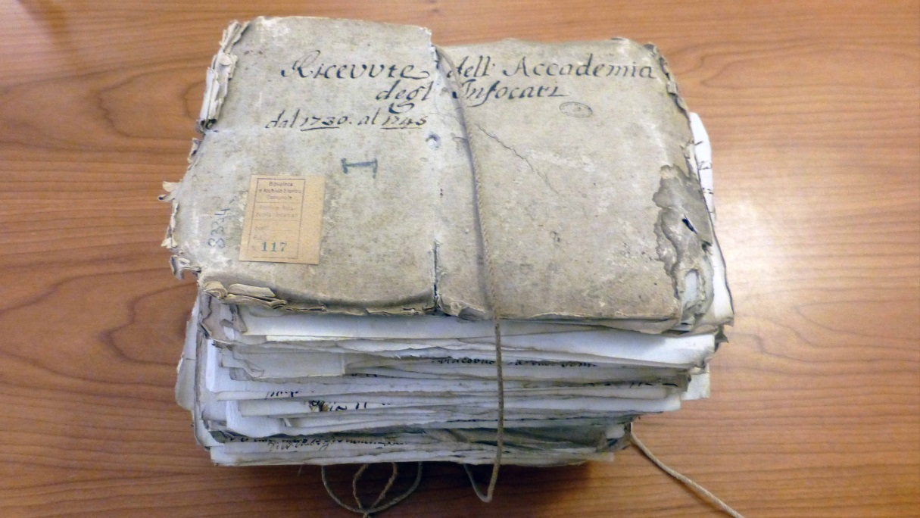

Figure 1 – Filza ASCFI TN 76.
Su concessione dell’Archivio storico del Comune di Firenze (5)

Francesco Rossi was the Florentine cardmaker, who supplied the playing-cards to the Stanze for the whole time interval taken into account. He in person wrote and signed the receipts of payment in the books TN 78 and TN 79. Only in rare occurrences, such as in receipt 181 of 1736, we find Giovanni Francesco Molinelli as a partial supplier (and Giovanni Domenico Molinelli as his heir).
The price of the new cards changed very little in the time examined. Consistently encountered prices were 14L. for a dozen packs of Basse and 19L. for a dozen of Minchiate. As alternative occurrences, packs of Basse can be found rated at 13L.10s. for a dozen.

The yearly amounts of card packs

Essential information is reported in the following table; it derives from the records copied in the appendix, and in particular contains the yearly values of ordinary cards and Minchiate, the total pack amounts, and the ratio of Minchiate to the total packs.

Year | Basse | Minchiate | Total | Ratio
1719 | 588 | 114 | 702 | 16,24
1720 | 564 | 114 | 678 | 16,81
1721 | 444 | 216 | 660 | 32,73
1722 | 456 | 222 | 678 | 32,74
1723 | 828 | 252 | 1080 | 23,33
1724 | 624 | 204 | 828 | 24,64
1725 | 624 | 180 | 804 | 22,39
1726 | 792 | 114 | 906 | 12,58
1727 | 780 | 132 | 912 | 14,47
1728 | 744 | 228 | 972 | 23,46
1729 | 744 | 132 | 876 | 15,07
1730 | 1068 | 126 | 1194 | 10,55
1731 | 840 | 78 | 918 | 8,50
1732 | 1188 | 124 | 1312 | 9,45
1733 | 1036 | 48 | 1084 | 4,43
1734 | 900 | 144 | 1044 | 13,79
1735 | 732 | 90 | 822 | 10, 95
1736 | 1476 | 60 | 1536 | 7,30
1737 | 1412 | 102 | 1514 | 6,74
1738 | 1244 | 54 | 1298 | 4,16
1739 | 1146 | 36 | 1182 | 3,05
1740 | 1080 | 72 | 1152 | 6,25
1741 | 1032 | 45 | 1077 | 4,18
1742 | 984 | 78 | 1062 | 7,34
1743 | 594 | 45 | 639 | 7,04
1744 | 390 | 12 | 402 | 2,99
1745 | 186 | 12 | 198 | 6,06
1746 | 470 | 12 | 482 | 2,49
1747 (part) | 368 | 0 | 368 | 0
.
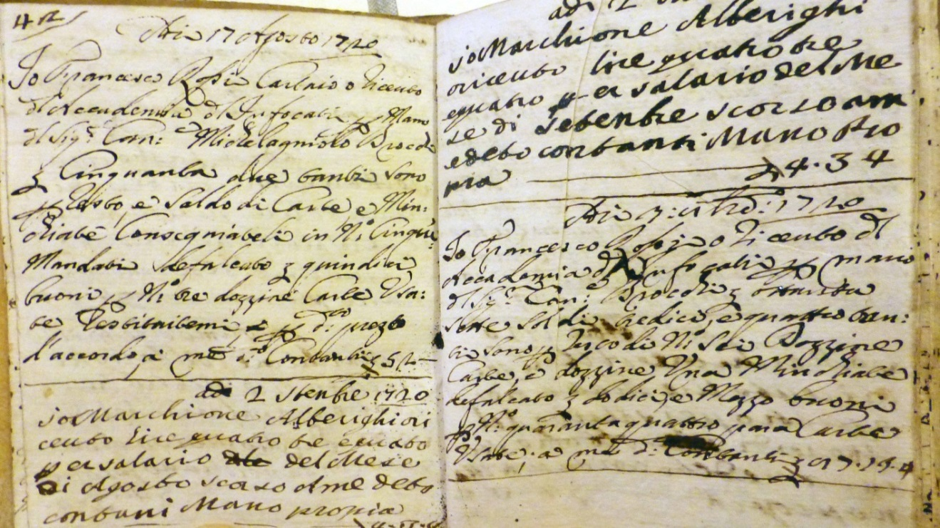

Figure 2 – Receipts written in ASCFI TN 78.
Su concessione dell’Archivio storico del Comune di Firenze (5)

In all entries of the register there is not any third kind of cards mentioned, always just Basse and Minchiate. There is no problem for Minchiate, because we know that the “standard” 78-card tarot was not used in Florence, at least in the 18th century.
We know that in the years examined in this study precisely Minchiate enjoyed an increasingly greater popularity throughout the whole of Europe, with many packs produced in Florence and exported abroad, especially in the largest European towns. It seems that the game was enjoying a special favour among the high classes. In Florence, however, the game appears as a traditional one, with a popularity lasting for centuries, without particularly drastic changes, even though showing a slow and continuous decrease. The exceptionally small amounts of Minchiate packs observed in the last months studied here is not a proof of their sudden disappearance: we know from many sources that this only occurred a whole century later on.
The problem arising from this new information is thus limited to Basse. Let us neglect the less familiar packs with 32 cards. In principle, there could be in common use both the 40-card pack, and the complete 52-card one; moreover, the traditional 40-card pack could be employed both in the Piccole and Grandi qualities.
My opinion is that there was just one kind of such cards in common use in the Stanze, namely Basse Grandi, corresponding to the larger variant of the 40-card pack. We are in the presence of administrative documents, and if various kinds of cards were traded, their cost was likely different and that difference should have been taken into account.
The simplest deductions from the new quantitative information obtained concern the total amount of cards used each year, and which was the fraction of Minchiate, both values being listed in the table above. Maybe the simpler way is just to comment on their average values. As average numbers we find about 900 packs of playing-cards, including 100 of Minchiate. The total values are remarkably lower (by about 40% less) that those found for the same years of the following century; moreover, the ratio of Minchiate to the total amount of card packs is lower, instead of greater, as we could expect.
In addition to discussing the average values, the yearly values help us to deduce further information. The general trend clearly indicated by the values recorded is that of a small increase of the “ordinary” cards in the course of time, with a contrary behavior of Minchiate.

Conclusion

This study is an extension of previous ones towards earlier times; in particular down to the years 1719-1747. We thus obtain further data on the consumption of playing-cards in the Stanze of Cocomero theatre in Florence. Hopefully, further documents can be found in the section Teatro Niccolini in the ASCFI, allowing to complete this research, with information from the years that have not yet been studied.

Notes

1. http://trionfi.com/evx-teatro-niccolini ; www.naibi.net/A/226
2. http://trionfi.com/evx-cocomero-2 ; www.naibi.net/A/228
3. www.naibi.net/A/302
4. Paolo Lucchesini, I teatri di Firenze, Roma 1991.
5. www.comune.fi.it/archiviostorico

APPENDIX

Purchases of playing-cards for the Stanze annesse al Teatro del Cocomero

The payment of the last column is usually not directly related with the amount of new cards, because the cost was partly paid through back selling variable amounts of second-hand cards.

RECORDS FROM ASCFI TN 26
Year | Mmdd | Basse | Minchiate | Payment
1719 | 0104 | 60 | 12 | 10.3.13.4
 | 0204 | 60 | 6 | 7.5.6.8
 | 0303 | 48 | 18 | 10.1.10
 | 0405 | 48 | 12 | 8.3.13.4
 | 0505 | 36 | 6 | 6.1
 | 0601 | 48 | 6 | 7.1.6.8
 | 0704 | 48 | 6 | 7.4.13.4
 | 0812 | 48 | 6 | 6.4.3.4
 | 0906 | 36 | 6 | 6.1
 | 1005 | 48 | 12 | 8.2.16.8
 | 1106 | 60 | 12 | 10.2.16.8
 | 1204 | 48 | 12 | 9.1.13.4
1720 | 0104 | 60 | 6 | 8.-.16.8
 | 0208 | 84 | 12 | 14.4.10
 | 0302 | 48 | 12 | 8.6.16.8
 | 0506 | 36 | 12 | 7.6.13.4
 | 0606 | 48 | 0 | 4.6.6.8
 | 0703 | 48 | 6 | 7.-.10
 | 0704 | 48 | 12 | 8.2.16.8
 | 0817 | 48 | 6 | 7.3
 | 1003 | 72 | 12 | 12.3.13.4
 | 1108 | 48 | 18 | 9.6.16.8
 | 1209 | 24 | 18 | 6.2.6.8
1721 | 0107 | 48 | 18 | 11.1.11.8
 | 0206 | 36 | 12 | 7.5
 | 0402 | 84 | 42 | 20.1.13.4
 | 0507 | 36 | 12 | 7.2.10
 | 0620 | 60 | 18 | 13.3.13.4
 | 0804 | 36 | 18 | 7.1.16.8
 | 0901 | 36 | 18 | 10
 | 1007 | 36 | 24 | 9.6.6.8
 | 1122 | 36 | 24 | 9.3.16.8
 | 1222 | 36 | 30 | 13.6
1722 | 0205 | 60 | 36 | 15.5.3.4
 | 0304 | 60 | 18 | 12.5.10
 | 0414 | 48 | 30 | 13.5
 | 0509 | 36 | 18 | 8.4.16.8
 | 0606 | 36 | 12 | 8.3
 | 0704 | 24 | 12 | 6.1.6.8
 | 0903 | 48 | 48 | 11.2
 | 1008 | 48 | 12 | 8.2.16.8
 | 1107 | 36 | 18 | 9.-.6.8
 | 1204 | 60 | 18 | 13
1723 | 0204 | 312 | 60 | 62.-.6.8
 | 0421 | 264 | 66 | 36.1
 | 0613 | 84 | 18 | 29.6
 | 0702 | 24 | 12 | 7.1
 | 0805 | 36 | 18 | 8.5
 | 1001 | 48 | 42 | 17.2.13.4
 | 1115 | 60 | 36 | 17.3
1724 | 0118 | 120 | 42 | 27.3.6.8
 | 0212 | 60 | 12 | 10
 | 0322 | 108 | 24 | 21.3
 | 0507 | 60 | 18 | 11.6.13.4
 | 0719 | 48 | 24 | 12.2
 | 0804 | 24 | 12 | 6
 | 0905 | 48 | 12 | 10.2.13.4
 | 1117 | 120 | 48 | 27.4
 | 1207 | 36 | 12 | 7.1.3.4
1725 | 0110 | 84 | 24 | 18.1.6.8
 | 0309 | 120 | 18 | 18.6
 | 0430 | 72 | 18 | 14.1.13.4
 | 0623 | 132 | 30 | 25.4
 | 0914 | 72 | 24 | 15.2
 | 1009 | 48 | 24 | 12.4.13.4
 | 1109 | 36 | 18 | 9.1.6.8
 | 1205 | 60 | 24 | 14.4.13.4
1726 | 0114 | 72 | 12 | 13.2
 | 0307 | 228 | 6 | 34.5
 | 0413 | 108 | 12 | 18.3
 | 0621 | 168 | 24 | 30.2
 | 0803 | 48 | 12 | 7.1
 | 1007 | 60 | 18 | 11.4
 | 1104 | 108 | 30 | 21.5.6.8
1727 | 0114 | 96 | 12 | 17.1.13.4
 | 0327 | 252 | 30 | 43.5.6.8
 | 0513 | 96 | 18 | 17.6.13.4
 | 0707 | 96 | 18 | 17.2.6.8
 | 0902 | 48 | 12 | 8.3.6.8
 | 1105 | 72 | 18 | 13.6
 | 1230 | 120 | 24 | 24.1.13.4
1728 | 0212 | 156 | 24 | 28.2
 | 0412 | 144 | 30 | 29
 | 0607 | 96 | 24 | 18.6
 | 0803 | 96 | 18 | 20.5
 | 0906 | 48 | 18 | 9.1.13.4
 | 1031 | 72 | 42 | 20.5.13.4
 | 1229 | 132 | 72 | 37.5
1729 | 0214 | 132 | 24 | 25.1
 | 0330 | 144 | 30 | 29.3
 | 0609 | 120 | 24 | 24
 | 0904 | 84 | 12 | 14.6.6.8
 | 1104 | 168 | 24 | 27.6.6.8
 | 1206 | 96 | 18 | 17.1.6.8
1730 (part) | 0117 | 132 | 24 | 24.5
 | 0301 | 144 | 18 | 25.5
 | 0401 | 120 | 18 | 19.2
 | 0430 | 48 | 6 | 8.2.6.8

RECORDS FROM ASCFI TN 76
Year | Mmdd |  | No. |  | Basse |  | Minchiate
1730  (part) | (0531) |  | 1 |  | 72 |  | 6
 | (0630) |  | 4 |  | 72 |  | 0
 | 0831 |  | 10 |  | 120 |  | 12
 | 0930 |  | 13 |  | 72 |  | 12
 | 1031 |  | 16 |  | 96 |  | 6
 | 1130 |  | 20 |  | 96 |  | 12
 | 1231 |  | 24 |  | 96 |  | 12
1731 | 0131 |  | 30 |  | 120 |  | 6
 | 0228 |  | 31 |  | 96 |  | 6
 | 0331 |  | 36 |  | 48 |  | 6
 | 0430 |  | 38 |  | 48 |  | 6
 | 0531 |  | 40 |  | 72 |  | 0
 | 0630 |  | 41 |  | 48 |  | 6
 | 0731 |  | 45 |  | 24 |  | 0
 | 0831 |  | 47 |  | 48 |  | 6
 | 0930 |  | 49 |  | 60 |  | 6
 | 1031 |  | 52 |  | 84 |  | 12
 | 1130 |  | 53 |  | 84 |  | 12
 | 1231 |  | 54 |  | 108 |  | 12
1732 | 0131 |  | 57 |  | 84 |  | 12
 | 0229 |  | 59 |  | 132 |  | 6
 | 0331 |  | 62 |  | 132 |  | 24
 | 0430 |  | 67 |  | 72 |  | 6
 | 0531 |  | 72 |  | 96 |  | 12
 | 0630 |  | 73 |  | 108 |  | 6
 | 0731 |  | 74 |  | 96 |  | 6
 | 0831 |  | 75 |  | 96 |  | 6
 | 0930 |  | 76 |  | 96 |  | 16
 | 1031 |  | 77 |  | 96 |  | 12
 | 1130 |  | 80 |  | 84 |  | 12
 | 1231 |  | 82 |  | 96 |  | 6
1733 | 0131 |  | 84 |  | 96 |  | 6
 | 0228 |  | 86 |  | 108 |  | 6
 | 0331 |  | 89 |  | 108 |  | 6
 | 0430 |  | 92 |  | 76 |  | 6
 | 0531 |  | 93 |  | 108 |  | 0
 | 0630 |  | 95 |  | 84 |  | 6
 | 0731 |  | 96 |  | 96 |  | 0
 | 0831 |  | 98 |  | 72 |  | 0
 | 0930 |  | 99 |  | 72 |  | 6
 | 1031 |  | 101 |  | 72 |  | 0
 | 1130 |  | 103 |  | 84 |  | 6
 | 1231 |  | 105 |  | 60 |  | 6
1734 | 0131 |  | 108 |  | 96 |  | 6
 | 0228 |  | 111 |  | 84 |  | 12
 | 0331 |  | 112 |  | 108 |  | 6
 | 0430 |  | 118 |  | 72 |  | 6
 | 0531 |  | 119 |  | 72 |  | 6
 | 0630 |  | 122 |  | 48 |  | 6
 | 0731 |  | 123 |  | 48 |  | 12
 | 0831 |  | 124 |  | 72 |  | 12
 | 0930 |  | 125 |  | 60 |  | 18
 | 1031 |  | 129 |  | 72 |  | 18
 | 1130 |  | 130 |  | 96 |  | 24
 | 1231 |  | 132 |  | 72 |  | 18
1735 | 0131 |  | 134 |  | 96 |  | 6
 | 0228 |  | 136 |  | 120 |  | 6
 | 0331 |  | 138 |  | 72 |  | 6
 | 0430 |  | 142 |  | 48 |  | 6
 | 0531 |  | 144 |  | 48 |  | 6
 | 0630 |  | 146 |  | 60 |  | 6
 | 0731 |  | 149 |  | 60 |  | 6
 | 0831 |  | 151 |  | 48 |  | 6
 | 0930 |  | 156 |  | 24 |  | 12
 | 1031 |  | 157 |  | 48 |  | 6
 | 1130 |  | 159 |  | 48 |  | 12
 | 1231 |  | 160 |  | 60 |  | 12
1736 | 0131 |  | 162 |  | 144 |  | 6
 | 0229 |  | 164 |  | 156 |  | 6
 | 0331 |  | 168 |  | 72 |  | 6
 | 0430 |  | 171 |  | 48 |  | 6
 | 0531 |  | 175 |  | 36 |  | 6
 | (0630) |  | 177 |  | 36 |  | 6
 | 0731 |  | 181 |  | 60 |  | 6
 | 0831 |  | 183 |  | 108 |  | 0
 | 0930 |  | 185 |  | 168 |  | 6
 | 1031 |  | 189 |  | 240 |  | 6
 | 1130 |  | 191 |  | 216 |  | 0
 | 1231 |  | 195 |  | 192 |  | 6
1737 |  | 0131 |  | 205 |  | 192 |  | 6
 |  | 0228 |  | 212 |  | 240 |  | 6
 |  | 0331 |  | 214 |  | 164 |  | 12
 |  | (0430) |  | 219 |  | 60 |  | 6
 |  | 0531 |  | 222 |  | 72 |  | 6
 |  | 0630 |  | 224 |  | 72 |  | 6
 |  | 0731 |  | 225 |  | 72 |  | 6
 |  | 0831 |  | 226 |  | 72 |  | 6
 |  | 0930 |  | 229 |  | 108 |  | 12
 |  | 1031 |  | 231 |  | 108 |  | 12
 |  | 1130 |  | 233 |  | 120 |  | 18
 |  | 1231 |  | 236 |  | 132 |  | 6
1738 |  | 0131 |  | 242 |  | 120 |  | 6
 |  | 0228 |  | 243 |  | 132 |  | 12
 |  | 0331 |  | 247 |  | 132 |  | 6
 |  | 0430 |  | 250 |  | 72 |  | 6
 |  | 0531 |  | 255 |  | 96 |  | 0
 |  | 0630 |  | 259 |  | 108 |  | 6
 |  | 0731 |  | 263 |  | 84 |  | 0
 |  | 0831 |  | 264 |  | 54 |  | 0
 |  | 0930 |  | 266 |  | 60 |  | 6
 |  | 1031 |  | 267 |  | 132 |  | 6
 |  | 1130 |  | 270 |  | 134 |  | 6
 |  | 1231 |  | 271 |  | 120 |  | 0
1739 |  | 0131 |  | 279 |  | 192 |  | 6
 |  | 0228 |  | 281 |  | 192 |  | 6
 |  | 0331 |  | 284 |  | 108 |  | 6
 |  | 0430 |  | 288 |  | 120 |  | 0
 |  | 0531 |  | 290 |  | 60 |  | 0
 |  | 0630 |  | 292 |  | 48 |  | 0
 |  | 0731 |  | 293 |  | 24 |  | 0
 |  | 0831 |  | 294 |  | 24 |  | 0
 |  | 0930 |  | 295 |  | 78 |  | 0
 |  | 1031 |  | 297 |  | 96 |  | 6
 |  | 1130 |  | 298 |  | 96 |  | 6
 |  | 1231 |  | 300 |  | 108 |  | 6
1740 |  | 0131 |  | 303 |  | 108 |  | 12
 |  | 0229 |  | 308 |  | 216 |  | 6
 |  | 0331 |  | 311 |  | 84 |  | 6
 |  | 0430 |  | 317 |  | 48 |  | 0
 |  | 0531 |  | 318 |  | 60 |  | 6
 |  | 0630 |  | 319 |  | 72 |  | 6
 |  | 0731 |  | 321 |  | 48 |  | 0
 |  | 0831 |  | 326 |  | 60 |  | 0
 |  | 0930 |  | 327 |  | 72 |  | 6
 |  | 1031 |  | 330 |  | 84 |  | 12
 |  | 1130 |  | 334 |  | 108 |  | 6
 |  | 1231 |  | 335 |  | 120 |  | 12
1741 |  | 0131 |  | 338 |  | 156 |  | 6
 |  | 0228 |  | 340 |  | 120 |  | 6
 |  | 0331 |  | 347 |  | 90 |  | 6
 |  | 0430 |  | 359 |  | 84 |  | 6
 |  | 0531 |  | 360 |  | 84 |  | 0
 |  | 0630 |  | 361 |  | 60 |  | 0
 |  | 0831 |  | 365 |  | 96 |  | 0
 |  | 0930 |  | 366 |  | 72 |  | 6
 |  | 1031 |  | 367 |  | 84 |  | 12
 |  | (1130) |  | 368 |  | 84 |  | 3
 |  | (1231) |  | 369 |  | 102 |  | 0
1742 |  | 0201 |  | 373 |  | 132 |  | 6
 |  | 0228 |  | 375 |  | 150 |  | 6
 |  | 0331 |  | 377 |  | 96 |  | 6
 |  | 0430 |  | 380 |  | 84 |  | 6
 |  | 0531 |  | 381 |  | 72 |  | 6
 |  | 0630 |  | 382 |  | 60 |  | 6
 |  | 0731 |  | 385 |  | 48 |  | 6
 |  | 0831 |  | 387 |  | 54 |  | 6
 |  | 0930 |  | 389 |  | 84 |  | 12
 |  | 1031 |  | 392 |  | 72 |  | 6
 |  | 1130 |  | 394 |  | 72 |  | 6
 |  | 1231 |  | 395 |  | 60 |  | 6

The numbering of the receipts (reported in the third column above) is interrupted in 1743, then it starts again from number 1, but it ends after a few instances and the following unnumbered receipts – a hundred or so − are only ordered by date.

RECORDS FROM ASCFI TN 76
Year | Mmdd | Basse | Minchiate
1743 | 0131 | 72 | 6
 | 0228 | 96 | 6
 | 0331 | 108 | 3
 | 0430 | 72 | 6
 | 0531 | 72 | 6
 | 0630 | 0 | 0
 | (0731) | 72 | 6
 | 0831 | 0 | 0
 | 0930 | 0 | 0
 | 1031 | 48 | 6
 | 1130 | 54 | 6
 | 1231 | 0 | 0
1744 | 0131 | 84 | 6
 | 0228 | 114 | 0
 | 0331 | 60 | 0
 | 0430 | 24 | 0
 | 0531 | 12 | 0
 | 0630 | 12 | 0
 | 0731 | 18 | 0
 | 0831 | 18 | 0
 | 0930 | 0 | 0
 | 1031 | 0 | 0
 | 1130 | 12 | 0
 | 1231 | 36 | 6

The last receipts in the folder TN 76 only cover the first four entries for 1745. The list can be continued using the last records of the register TN 26, which however appear less reliable and complete than those of previous years.

RECORDS FROM ASCFI TN 76 AND TN26
Year | Mmdd | Basse | Minchiate
1745 | 0131 | 48 | 0
 | 0228 | 72 | 6
 | 0331 | 48 | 0
 | 0430 | 18 | 6
1746 | 0228 | 72 | 6
 | 0531 | 22 | 6
 | 0630 | 38 | 0
 | 0731 | 36 | 0
 | 0831 | 30 | 0
 | 0930 | 54 | 0
 | 1031 | 56 | 0
 | 1130 | 84 | 0
 | 1231 | 78 | 0
1747 | 0131 | 113 | 0
 | 0228 | 113 | 0
 | 0331 | 82 | 0
 | 0506 | 60 | 0

