1428: NAIBI COMING TO ROME
Franco Pratesi, 18.03.2013

INTRODUCTION

I have been stimulated to write this note, after some reflection on the little known early card trade in Rome. With the present note, I do not introduce new and unknown elements into the history of playing cards, but am only commenting on some information already present in the literature.
The information to be discussed comes from the year 1428 and the city of Rome. It is important to understand, first of all, the simple reason of these limits in space and time. Only from Rome have detailed customs documents been kept; in other towns, they usually existed too, but in the course of time only part of the cash books have been preserved, in which the totals had been recorded, without specifying the single contributions to those incomes.
On the other hand, the reason for selecting the year 1428 is due to pure chance. Out of the yearly registers of the Roman customs offices only this one has been kept for the time interval under examination: there is none before it, and the next one is already dated in 1444. An obvious consequence of the situation mentioned is that what we see cannot be used to suggest anything sure about previous or following years. We must be satisfied with this very narrow window, which we find opened for controlling the history of playing cards.
Now, having firmly established that this 1428-and-Rome association is not at all the result of any scientific selection of a suitable target for research, we have to briefly inspect the local situation at the time.

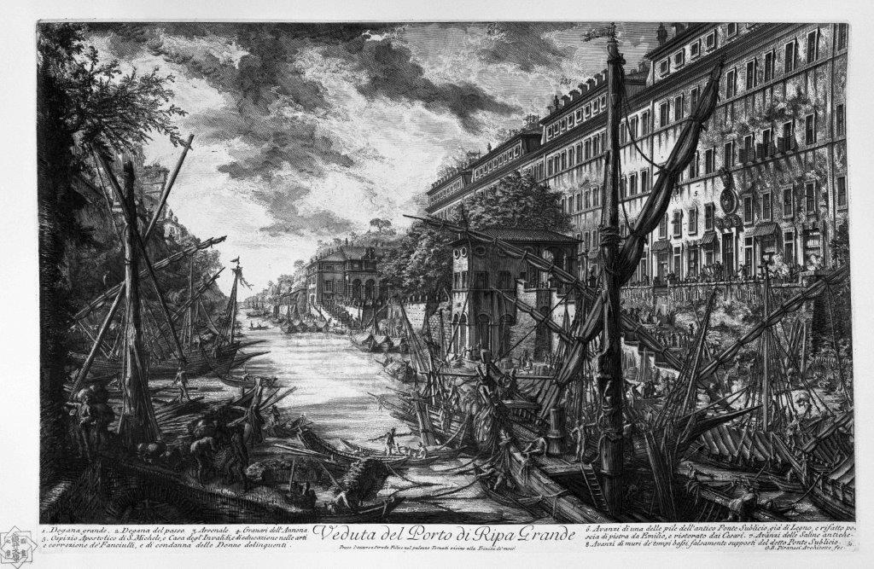

Figure 1 – Giambattista Piranesi: Porto di Ripa Grande (from Wikimedia Commons).

Another association that is unavoidable to mention is that between Rome and Pope. Actually, this association had encountered a lot of problems in the previous years, with two or three Popes present together in different towns, to begin with Avignon. At the time, the Pope was Martin V, and it had been precisely with him that the Western Schism (1378–1417) had come to an end. (1)
In 1428, Pope Martin V had again translated his court into Rome. He had been elected in 1417 and had mostly acted out of Rome in the first years of his charge; for instance, in 1419 and 1420, before coming to Rome, he stayed with his court in the Florentine convent of Santa Maria Novella. (2) His arrival into Rome had thus enough time to be prepared in some detail. Some preparation was reasonably required because of the long absence of the papal court from Rome.
When in Rome again, the Pope carried out several reforms and changes in the administration and the offices. One of his activities was addressed to improve the situation of the town, with new exceptional buildings and extended flourishing of arts and crafts.
What is of particular interest here is that also the local commerce increased significantly both in quantity and quality. It is obvious that Rome with or without the presence of the Papal court was not the same city; by the way, the town population at the time was reduced to about 30,000 inhabitants.
The merchandise entering the town consisted mainly of food provisions. In particular, various qualities of wine arrived from many places and in big quantities. However, we assist in that year to an enhanced supply of the most various goods entering the town; among them, it is not too much surprising that we find playing cards as well.
Of course, playing cards could only represent an infinitesimal amount of the whole trade; nevertheless, discussing the corresponding information may be worthwhile.

A − CONTRIBUTIONS BY SCHOLARS

As historians of playing cards, we are fortunate in finding that the documents under examination have already been examined by professional researchers, at the highest level, as indicated in the following.

A1 − Arnold Esch

This is the first name that we encounter. We are in the presence of an academic scholar; in particular, he has studied the registers of the Roman customs for many years, and has published several papers on that topic. Some of these articles were then jointly published in a book, (3) which contains some additional unpublished material.
It is evident that, as it was to be expected, the interest of Arnold Esch was not specifically addressed to playing cards: in case, art objects were the key topic of his research. Even if his interest was that of a professional art historian, he did not neglect more general aspects and his analysis of the goods traded and the discussion of their quantities and prices finally included everything that could interest any historian of the Roman social life at the time.
In particular, coming to matters of our specific interest, he did not ignore the information kept in the customs books about the trade of playing cards. We can thus find in his publications an extraordinary source of data, with specific information for those years more detailed than anywhere else.
These important new records were not received at once by card historians. It has been the merit of a few of them to have let this information be known within the world of card collectors and historians. To begin with, one has to mention Thierry Depaulis, who first published and discussed relevant information from Esch’s articles. (4) Further data from the Esch’s book were communicated by Ross Caldwell, (5) and one particular record of Trionfi in 1453, only present in the same book, was discussed by me in the first note of this series. (6)
After recurrent discussions with Lothar Teikemeier, who was hoping in further data from the Roman customs, in the spring 2012 I sent a letter to Arnold Esch asking for further information, if existing. I have no sure knowledge how much this has stimulated the specific interest by Arnold Esch into this particular topic. What is certain is that we finally encounter a seldom occurrence: a real academic researcher, with a long experience of original research in the archives, who focuses his attention on the history of playing cards, hardly an acceptable field at that level.
Unfortunately, the specific article by Arnold Esch of our main interest has been submitted for publication to the Gutenberg Jahrbuch. (7) This prominent journal has for us the drawback implied in its name itself: it is a yearly publication, and a long time has been required for “our” article to get printed. In the meantime, however, Arnold Esch has been so kind to inform me of some essential points before publication. In particular, it has been he in person to call my attention to Lombardo’s book, concerning the customs register of 1428, examined below. (8)
I will thus pass now to examine Lombardo’s book, but must anticipate that the specific information derivable from it has already been found and described in the mentioned article by Arnold Esch. (7)

A2 – Maria Luisa Lombardo

At the origin of the information commented in this note are the studies of Maria Luisa Lombardo, who studied the documents of the Roman customs with care. She dedicated a preliminary research to examining the extant registers and determining the structure and the organisation of the whole system; as a result, she published a book, containing all the relevant information. (9) She noted, among other topics, that the series kept was a rather regular one, beginning in 1444 and continuing with only a few missing yearly registers. For the previous years, only the register of 1428 had been kept.
Later on, the same researcher devoted a whole book to this isolated register; (8) her book contains a detailed study with analysis of the ships, owners, pilots, merchandise, harbour of origin, and so on. In addition to this specific study, involving several quantitative analyses, she inserted in the book the whole transcription of the register under examination.
Our particular interest is focused on just two shipments, which contained playing cards, but it is easy to understand that this represents an extremely small part of the commerce that can be “seen” through the register; it is this whole commerce that the author has analysed in depth.
The two shipments mentioned can easily be traced in the transcription of the document at the end of Lombardo’s book. Moreover, the same shipments containing playing cards can already be found discussed in the previous part, in which the whole trade is analysed. Further information on this point can be found below.

B − THE SPECIFIC CARD TRADE

Having duly explained that the part of our interest only concerns an infinitesimal part of the documents, let us concentrate our attention into it, after acknowledging that the information on the trades of wine, grain, countless products, and raw materials as well, is clearly much more important for the history of the time.

B1 − Ships and loads

Some information we have also on the ships involved in the trade. At the time, there were many kinds of them, of various shapes and tonnage. Most of those arriving in Rome and paying the customs duties are just indicated as barca, or boat. In our case, they were of the sagezia or saettia family, and – as the name may suggest, being connected with saetta or arrow – were thinner than usual and accordingly could be faster.

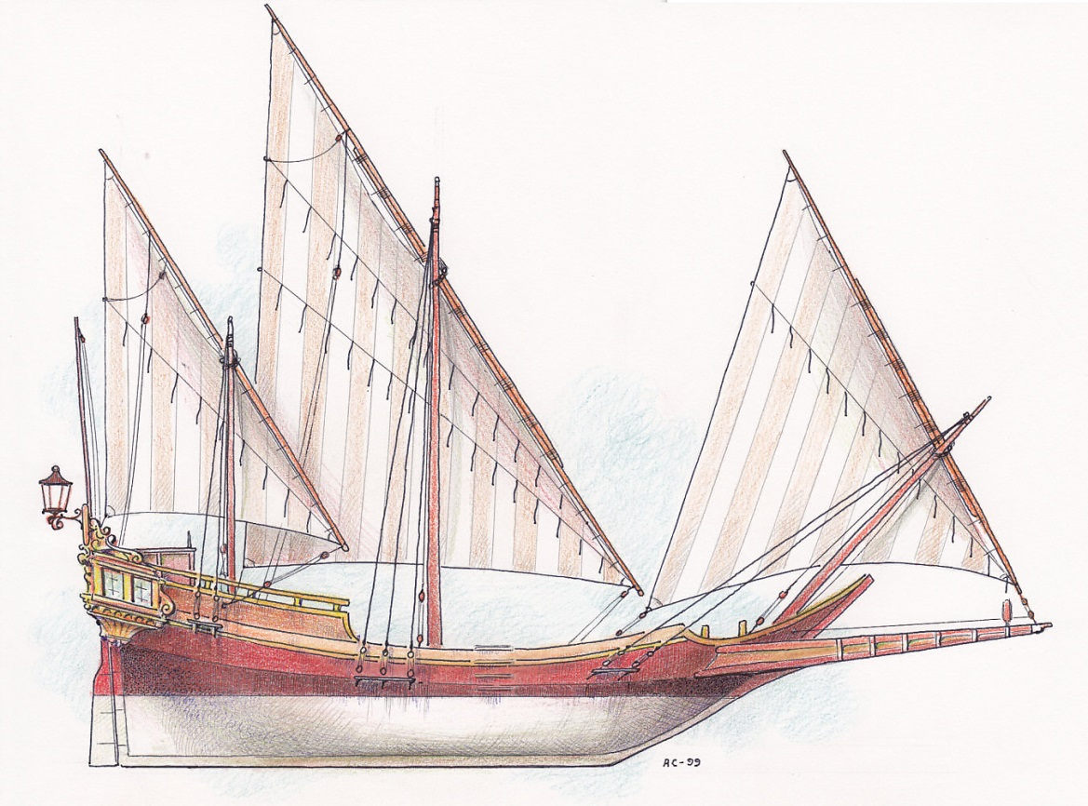
Figure 2 – Illustration of a Saettia (from trionfi.com).

This does not mean that these particular ships were smaller than average, especially among those that could arrive into Rome; on the contrary, the corresponding loads were among the heaviest recorded in 1428, or at least those paying the highest customs duties.

B2 − Other goods in the same load

As a rule the load of any ship consisted of several distinct parts, different both for contents and addressee. We have thus to examine the whole load, as the customs officials did, separately according to those components. Let me just copy here how Lombardo indicates, in Italian, the contents of the two loads of our interest, whereas the full Latin text of the document is copied at the end of this note.
On 20 April 1428: vino greco, sapone, olio, cuoio, tarocchi, cera barbaresca, panni, smerigli, aranci, rabarbaro, agarico, sporte vuote, spago, specchi piccoli e grandi, piccole sporte, zolfo, piatti di maiolica, sedie di legno. The sum of all the customs duties paid for all these items was fl.163 s.4 d.3.
On 25 June 1428: vino fraiano, vino latino, pale di legno, ceste, cuoio, tarocchi, un recipiente vuoto, cuoi pelosi, pignoli, acciaio, aranci, carrube, fustagno, piatti. The sum of all the customs duties paid for all these items was fl.153 s.9 d.9.
It may be interesting to know that the contribution to the customs duties coming from the Naibi packs was of the order of one hundredth of the duties collected from the total shipload. (As for the unexpected presence of Tarocchi, see below.)

B3 − Goods sent to the same addressee

We have to provide a special attention to any merchandise that accompanied the Naibi, addressed to the same beneficiary, named Antonio Sabatino. There are two further records with his name: together with Naibi, he receives a second article, a bundle of leathers.
These bundles of leathers are worth discussing. Unfortunately, this kind of merchandise does not provide a strong hint to its provenance. Leathers could be local products, or come from any far country. In some cases, we find pelli barbaresche mentioned, suggesting an origin from the Barbary Coast, but here no attribute is present.
On the other hand, the fact that leathers and Naibi were present together and with the same addressee is a hint to a possible common origin, not a proof; in principle, their provenance could be different.
Somewhat surprising may appear the cost of this merchandise, and especially the comparison of its estimated value with that of the playing cards. If we can assume that one florin corresponded to 20s. and reduce the money amounts to Soldi, we find the following results. Estimated values of the leathers: 2000 s. on 20 April and 2200 s. on 25 June, with respective duties of 143.50 s. and 146.50 s. Estimated values of the Naibi packs: 260 s. in both cases, with the corresponding duty of 40 s.
There may be something wrong in these values, but it is evident that the leathers were at least more than three times as expensive than Naibi. Of course, the bundle of leathers could contain a lot of them; these leathers could be more expensive than usual; in any case, the Naibi present together could not be a precious merchandise.

B4 − The container of the Naibi packs

It may be easier to deal with the container of the cards than with the cards themselves. Actually, it is indicated as a scrigno, a word that in the course of time has assumed the meaning of treasure chest. As such, the word is still in common use, and it may become misleading in our case, letting us think of something more precious than it really was.
After some reflection, we can accept that it was nothing else than a packing case; however, for a common packing case they had current terms available, such as cassa. Which special features were present in this case? It could be somewhat decorated, made with a costly wood, or probably just with a smaller size, nothing very special in any case.

B5 − Amount of card packs

The amount of the cards packs is not indicated and cannot be derived from the information recorded. It is however clear that the shipment did not involve only one card pack, and not even a few of them.
Also admitting a middle dimension for the case, it is stated that it was full of cards, which may let us envisage for the packs a quantity of the order of magnitude of one hundred. Let me indicate, just as a possibility, a gross, a dozen of dozens.

B6 − Kind of playing cards

Extremely surprising at first sight is the mention of our playing cards in the initial part of Lombardo’s book: they are indicated as Tarocchi. This does not occur by chance, in just one case; they are systematically indicated as such, whenever they are mentioned.
Now, finding Tarocchi in 1428 may not represent a wholly impossible event, even though their presence would have been more acceptable a dozen years later on, and in different places, and under a different designation. If really we can read the word Tarocchi written in the original document, this would represent a revolutionary progress in our knowledge of the matter.
However, when we check how our playing cards are indicated in the original register, what we read there is Naibi. Naibi is an Italian word that is familiar to historians of playing cards, and I have personally met it countless times in my studies. If however a pack of playing cards is now mentioned as Naibi it is likely that this is only understood... in Spain.
If Lombardo wanted to avoid using the unknown word of naibi, she had to call them carte da gioco, and not tarocchi. Why did she “translate” this specific term wrongly? This mistake is not without an explanation. As a matter of fact, there is a long tradition in the literature on playing cards with recurrent confusion about whether the term Naibi has to be associated with common or special cards.
In other words, if we search a support for Lombardo’s interpretation of Naibi as Tarocchi, we can compile a long list of references, including some from recognised authorities. Our task is however simpler than that, because Lombardo explicitly mentions her source as Sella’s Glossario, with the following statement for Naibi: Giuoco dei tarocchi introdotto in Italia verso la metà del sec. XIV dalla Spagna o dai Catalani, ai quali era pervenuto dagli Arabi. (10)
This clearly had appeared to her as a reliable explanation of the real meaning, but it is not. If it is true that Lombardo’s mistake can be supported by a lot of past references, in addition to the one quoted by her, it is also true that this remains a mistake, which cannot any longer be justified in dealing with playing cards with a bare minimum of competence.

B7 − Card price

What we have as indication for the price of these cards is only a cumulative estimated value of 13 florins. Now, I meet some difficulty with these Roman account books, as I am only familiar with the corresponding Florentine ones, and their common system L.s.d.; here we have instead florins mentioned (but this may be a mistake in reading the unit of currency). Our specific case can actually be read, precisely as in Florence, in the following way: the estimated value is 13 L., which gives exactly 40 s. as the corresponding 6.50% duty, if this is calculated with the usual 1L.=20s. correspondence.
Clearly, the unit price for pack will be the lower, the more packs are present in the scrigno. A rather arbitrary suggestion could be an average price around 2 s. for a gross of 144 packs. As a general consideration, the price had to vary in a small range: it could not be too low, because it had to correspond to cards made for export; it could not be too high, because it had likely to compete with similar packs with lower customs and shipping fees.

C − PERSONS INVOLVED IN THE TRADE

We only observe a part of the transit of the cards from producer to consumer. Various persons were involved, but for most of them we can only propose speculations, as in the following sections.

C1 – Producer and dispatcher

It would be very interesting to associate with these Naibi the names of their producer, or at least the name of the person who shipped them to Rome. Unfortunately, this is not possible, and we only can propose several hypotheses on the place of production and on the places of transit, if any, of these Naibi, as can be found in a following section.
As in other cases of these trades, it seems however that missing the name of the dispatcher is not a great loss, because it seemingly was the addressee to care for selecting the merchandise to be shipped to him. The merchandise was indicated with his name, and it was he in person to enter the customs offices and pay the customs duties. The payment did not occur as a single affair for the whole load of the ship, but separately for each of its various parts, personally by the various addressees.

C2 – Owners and captains of the ship

Here we are more fortunate: we know the names of the owners of the ships and of their pilots or captains. (Lombardo uses for them the names of proprietario o patrono and patrono, respectively.) The first ship had Lorenzo Altieri as ship-owner and Giovanni Varrone as captain; the second ship had again as owner Lorenzo Altieri – this time however together with Luca Nannoli − and Iuliano Bulgaminis as captain.
Reading these names does not add much interesting news to our information, in the absence of further data. Most noteworthy, however, appears the fact that all these persons have been indicated as being from Gaeta, which obviously gives more weight to that town and its fundamental participation in this trade.

C3 – Beneficiary

Out of the several names encountered, the name of the receiver of our Naibi, Angelo Sabatino, is of course the most interesting for us. Regrettably, I have not been able to find any further information about him, his life, and his trades.
It must however be stressed that his presence in the trade is not due to an accidental event. We find two shipments of Naibi, in different months, with different ships: in both cases, the cards are addressed to the same person.
It would be interesting to find the same person quoted in other trades, as receiver of other goods belonging to other shipments and loads. Regrettably, in the register of 1428 there is no record of shipments in which he was involved, except the two cases examined.
Remarkable is however the fact that he was not trading cards only. The bundles of leathers that come together were valued more than the cards; they corresponded better to a traditional trade, which had been very active even before the introduction itself of the playing cards into Europe. Seemingly, Angelo Sabatino at a given time had added the secondary trade of Naibi to his primary trade of leathers.
On the other hand, the amount of card packs received by him is enough to exclude any trade for personal use. Our Angelo Sabatino receives the Naibi to further trade them. As for the previous stages, also for the continuation of this trade we have no information and can only speculate.

C4 – Consumers

About the players who used these Naibi we only can speculate. It is likely that some further trade occurred between Angelo Sabatino and the final consumers of these cards, maybe mercers selling by retail. My impression is that the final destination was toward the middle-class, if we can apply this term at the time.
In particular, these Naibi clearly do not appear as precious goods, addressed to someone in the papal court. Moreover, if the Naibi were addressed to the court, these personages would have received them without paying any customs duty. Two such cases are present in these loads: olive oil and soap for the Saint Sabina cloister, as well as wine and marzipan for the Cardinal of Aquileia arrive duty-free.

D − TOWNS INVOLVED IN THE TRADE

We read that these cards started from Gaeta and arrived into Rome. It is apparent that Rome actually was the final destination, but it could be such only in part, with some packs to be forwarded into neighbouring towns. On the other hand, it seems that Gaeta could hardly be the place where all these Naibi had been produced. We thus have to discuss several possible paths for the whole travel of these cards.

D1 – Possible towns of fabrication and transit

We have no direct information on the travel of these cards up to Gaeta, but we have reasons to believe that the cards arrived there from other places. We have thus to search for plausible places in order to reconstruct the preceding part of their travel; let us go backwards, in the contrary direction with respect to the real travel.
Starting from Gaeta, the first stage is very easy to find. We cannot be seriously wrong in supposing that the cards had arrived in Gaeta from Naples. As a matter of fact, it was Naples the big commercial harbour of South Italy, the chief town that acted as the fundamental centre for trades of any kinds of goods coming from everywhere in the Mediterranean Sea and farther away.
If passing from Gaeta to Naples has been easy, proceeding farther becomes instead very difficult. In particular, there was an established course in which they had a Naples-Gaeta stage. The starting point was near Genoa. Actually Genoa was the big harbour and it could be supposed to play the major role in the traffic. This actually occurred with the biggest ships arriving in Naples from various far places. However, we know that several minor harbours to the East or to the West of Genoa were mainly involved in the courses with stops at Gaeta.
Now, there were many ships from Liguria which brought goods into Naples, either to be used there or to be further traded and shipped in any other direction. These goods could come from Milan, Bergamo, Provence, or even farther to the North. The goods could consist of some products of smiths, goldsmiths, particular clothes, or any other kind of goods or raw materials with a Northern provenance.
In Naples, these ships were unloaded, and loaded again with products coming from the South, mainly Mediterranean provisions. The Naples-Gaeta stage was thus just the first stage of the return part of a round trip.
The main problem in associating the trade of our Naibi to that traditional course is that the two ships involved in our case did not belong to one or another of the Ligurian fleets: they were both based in Gaeta. Thus, the supposed Naples-Gaeta stage remains a valid hypothesis, but extending it to Genoa and further locations becomes less plausible.
Even if one can neglect any provenance from the North, it is not easy to select a plausible course for our cards in arriving to Naples. We are thus left with a lot of possible hypotheses, unfortunately impossible as yet to prove.
Having found a rich production and trade of cards in Florence at the time, I would like to suggest a Florentine origin for these cards. My strong parochialism is however not enough to let me imagine a travel from Florence to Rome passing through Gaeta. There could be particular situations justifying that strange path, but I am not able now to envisage any of them.
We know that Florence was a very active centre of playing-card production. If we exclude it as a possible provenance of our cards, as seems to be necessary, we are left with the problem of discovering another similar centre of production and trade.
An easy solution to the question would be to suppose that these cards had been produced in Naples itself. This is a suggestion that cannot be excluded. However, if Naples were an active centre for the production of Naibi, I imagine that we could find several confirmations in the documents of the time. On the contrary, I am not familiar with any of them.
Let us thus go on with our travel. Which could be the Mediterranean harbour of provenance? There were countless of them. We can begin with the African coastline, where many provisions and goods actually came from.
In our case, interesting seems to think of Egypt, just because the very introduction of Naibi into Europe is currently supposed to derive from the Mamluk culture of Egypt. An hypothesis of this kind has the advantage that only half a century had passed since the introduction of playing cards into Europe. The negative aspect is that from Egypt we hardly have news of card playing, not to mention of card producing in amounts compatible with trade and export.
We have to pass through the whole African coastline up to reaching the Gibraltar strait and proceeding farther to Morocco. This is the Barbary coast, which actually was the source of much merchandise, currently indicated as barbaresca, arriving into the Italian harbours. Some goods with this attribute we even find in the same load where Naibi are recorded. Maybe, the most likely part of that coast is the farthest one, corresponding to Morocco, where leathers and other goods frequently came from.
Let us go on crossing the Gibraltar strait and advancing along the coasts of Spain. It becomes easy to find again harbours that had a fluent commerce with Naples and any other European place. The suggestion of such a provenance has the advantage that it could be valid both for local products and for products coming from Africa, or even for raw materials coming from Africa and processed in Catalonia.
It becomes here unavoidable to think of Valencia and Barcelona as possible sources of our cards. The Majolica plates present together may provide a further hint in that direction. We have little or no information on an outstanding production of Naibi there, supporting a significant trade at the international level at the time, but in case this could easily be associated with the rich commerce of other merchandise, for which many records are kept.

D2 – Gaeta

With Gaeta, we have finally arrived at a firm point. We have no longer to imagine more or less plausible reconstructions; Gaeta really was the place where our Naibi came from before the ships were unloaded in Rome.
Again, we have to examine first if our Naibi could have been produced there. In my opinion, Gaeta was not big enough to support the establishment of a production of Naibi in quantities enough to be traded and exported. I prefer to suppose that they had arrived there from other places, and this has already been discussed in the previous section.
It remains to understand the role of Gaeta as a harbour of transit, especially between Naples and Rome. I have not studied the question in detail, but the information that we can derive from Lombardo’s book (8) seems to me more than enough. In a way similar to what had occurred in many minor harbours near Genoa, also near Naples one could find several harbours active in the trade and shipments of the most various goods; Gaeta was represented by six ships, but at least one ship came from Ariano, Ischia, Maggiore, Pozzuoli, Salerno, and Sorrento.
Obviously, as for every shipping net, from minor harbours of this kind one could better expect shipments directed to places not too far, navigating along the coast, and using smaller ships. This kind of transport often included stops at intermediate harbours with partial changes of the shipload.
All the ships arriving into Rome in 1428 have been examined in detail by Lombardo and she concluded that Gaeta indeed was one of the most frequent towns of origin. In other words, the two ships that brought the Naibi to Rome were part of a numerous fleet of boats and ships of various tonnage, and the Gaeta-Rome stage was a very popular one.
That Rome and its territory needed great supplies of food and many other merchandise is easy to understand, and another known fact is that provisions of grain, wine, oil, fruits, cheese, and so on, were all preferentially of Southern provenance.

D3 – Rome

Rome became again a big city some years later on, and precisely the activity of Pope Martin V contributed to its new flourishing. However, the inhabitants at the time were only about 30,000. What distinguished this town from others of similar extension was of course the papal court and its richness.
Between the citizens and the Pope there was a very rich intermediate class of cardinals, prelates, ambassadors, and their employees. It is easy to understand that in 1428 the town was in the course of an increasing flow of money and goods, much above the past level, limited to just the indispensable provisions. Now, superfluous items could be traded for satisfying the new, or increased, request of precious clothes, special foods, and even art objects.

D4 – The Papal State

In addition to represent in itself a remarkable market, Rome was at the same time the chief town of the whole Papal State. This had an extended territory on both sides of the Appennini mountains, and included a lot of little and middle-sized fiefs, more or less connected with the papal administration.
I do not believe that Naibi were specially addressed to the courts, but in case the Papal States abounded in lord courts, down to the smallest possible dimensions. Other plausible beneficiaries could be the many warlords and their soldieries, who were by then active in several parts of the papal territory.

CONCLUSION

Records are kept in the registers of the Roman customs of two chests full of Naibi arriving in 1428 into Rome from Gaeta. Each of them had an estimated value of thirteen florins and was addressed to Angelo Sabatino, together with a bundle of leathers belonging to the same shipment.
On the basis of the evidence mentioned, several suggestions have been discussed with the aim to complete the trade channel of these playing cards from their producers to their consumers. In the absence of further documents, no clear-cut conclusion can be reached, but a more complete framework of the plausible steps of that trade has been outlined.

NOTES

(1) http://en.wikipedia.org/wiki/Pope_Martin_V

(2) http://www.treccani.it/enciclopedia/martino-v_%28Enciclopedia_dei_Papi%29/
(3) Arnold Esch, Economia, cultura materiale ed arte nella Roma del Rinascimento. Roma 2007.
(4) Thierry Depaulis, The Playing-Card, Vol. 36 No. 3 (2008) 205-211.
(5) http://forum.tarothistory.com/viewtopic.php?f=11&t=743
(6) http://trionfi.com/triunfi-playing-cards-rome
(7) Arnold Esch, Gutenberg Jahrbuch, (2013) pp. 41-53.
(8) Maria Luisa Lombardo, Camera Urbis. Dohana Ripe et Ripecte. Liber introitus 1428. Roma 1978.
(9) Maria Luisa Lombardo, La Camera Urbis. Premesse… Roma 1970.
(10) Pietro Sella, Glossario latino-italiano. Città del Vaticano 1944.

APPENDICES

1 − Document of the first shipment discussed in this note

Indictione .VI. mensis aprilis die .XX.
Iohanne Varrone de Gayeto portavit in sagetia Laurentii Alterii:
.XXVIII: vegetes vini graeci, unum quartarolum eiusdem vini Aloyscio de Cantone;
unum carratellum greci domino Arnaldo;
.XXII. sacchos saponis, duos carratellos olei Laurentio Alterii;
unum quartarolum olei, unam cistellam saponis monasterio Sancte Sabine. Non tenetur solvere propter bullectam;
.VI. fascios coraminis Angelo Sabatino;
unum scrignum plenum de naibi eidem Angelo;
.IIII. panes cere barbaresche Luce Nannoli;
unam cistellam de smerigli Colelle Ciciliano;
melangolos ipsius Iohannis Varonis;
duas libras reubarbari, unam libram agarici, .XXX. sportas vacuas, unam sacchectam de spaco, .VI. doçinas de specchi piccoli, .XVI. specchi grandi, .III. doçinas de sportellini, unum barile sulfuris, .XII. plactellos de Maiorica marinariorum;
.IIII. sedes ligneas Francisco Boscoli.
…
Item recepit [dictus Camerarius] a dicto Angelo pro dicto coramine extimato fl. C
fl.6 s.23 d.6
Item recepit [dictus Camerarius] a dicto Angelo pro dictis naibis extimatis fl. XIII s. 40
Summa huius sagectia fl.163 s.4 d.3

2 − Document of the second shipment discussed in this note

Indictione .VI. mensis iunii die .XXV.
Iulianius Bulgaminis de Gayeto portavit in sagectia Laurentii Alterii et Luce Nannoli:
.XXVIII vegetes, .VIII. caratellos frayani Laurentio Alterii;
.IIII. vegetes latini, unum mazapane sigillatum domino cardinali de Aquilea. Transiverunt per bullectam;
centum palas ligneas, .XL: corbellas Pectro de Neapolim;
.VIII. fascios de corame, unum scrignum plenume de naybi Angelo Sabatino;
unam iarram vacuam Meo tabernario;
.VI. coria pilosa Luce Nannoli;
unam cistellam de pignoli, duos ballones de acciaro, melangolos, unam sportam de sellecole, .XVIII. cannas de fustaine, .VI. dozinas plactellorum de Maiorica marinariorum.

(…) Item recepit [dictus Camerarius] a dicto Angelo pro dictis .VIII. fascis de corame extimatis fl. CX pro iure dohane fl.7 s.6 d.6
(…)
Item recepit [dictus Camerarius] a dicto Angelo pro dictis naibus extimatis
fl. XIII s.40
Summa huius sagectia fl.153 s.9 d.9

